Sports Underdog PSMT – Eden Tomes

# Introduction:

Stories of unexpected underdog triumphs hold a significant place in competitive sports culture, with their occurrence causing commotion amongst fans of winning and losing teams alike. A prevailing argument from resentful fans speculates that weaker teams have a higher likelihood of success in shorter competitions due to reduced opportunities for the stronger team to assert dominance. This report investigates the validity of this claim by analyzing how the length of an NBA playoff series impacts a below-average team’s odds of winning, comparing the success rate for a 7-game, 5-game, and 3-game series. By comparing and analyzing success rates across these differing series formats, this study aims to quantify the relationship between series length and underdog performance, providing insights into tournament design and competitive fairness.

# Observations:

* Different sports competitions have varying numbers of rounds, which is significant because it provides the basis for investigating whether more rounds affect a weaker team’s chance of winning.
* Examples like Emma Raducanu and Morocco’s World Cup run demonstrate that underdogs do occasionally succeed in high-profile competitions. This is important because it provides real-world examples that support or contradict the claim being investigated.
* There appears to be general interest in whether competition structures provide fair opportunities for all participants, especially underdogs, establishing the relevance of the investigation.

# Assumptions:

* To test whether weaker teams have better chances in competitions with fewer rounds, it is assumed that a team’s “strength” can be measured/defined by their winning percentage. This is significant because the entire claim hinges on being able to identify which teams are “weaker”.
* It is assumed that mathematical probability models can accurately represent the outcomes of sporting competitions, despite not considering outside factors that affect a team’s performance. This allows the claim to be tested and analysed using statistical methods.
* It is assumed that there is some element of randomness or chance in sporting outcomes, not just pure skill differences. This is significant because without this assumption, stronger teams would always win regardless of the number of rounds.
* It is assumed that increasing the number of rounds reduces statistical variance and allows true skill levels to emerge more clearly. This is a key assumption that directly relates to testing the claim.
* It is assumed that the chosen real-world data (regular season record of the 2024-2025 Chicago Bulls, as of 15/02/2025) is representative of the typical underdog team. This is crucial, as it ensures the results of the simulation model are meaningful in evaluating the relationship between competition format and outcomes.

# Method:

To investigate the impact of series length on underdog success, a probabilistic simulation model was developed using Microsoft Excel. The NBA Chicago Bulls’ 2024-25 regular season win rate (0.400, as of 15/02/25) served as the underdog’s probability of winning any single game. Three series formats were analyzed: 7-game (first to 4 wins), 5-game (first to 3 wins), and 3-game (first to 2 wins).

## Simulation Setup:

For each series length, 1000 independent trials were conducted. Each game outcome was determined using Excel’s =RAND() function. A value below 0.4 recorded an underdog win; otherwise, a loss. The series concluded once the underdog or opponent achieved the required number of wins (e.g. 4 games in a 7-game series).

Data Collection:

The total series wins by the underdog were recorded for each format. The percentages of trials won were calculated as: $$\text{Win} \text{Percentage}=\frac{\text{Number} \text{of} \text{Series} \text{Won}}{\text{Total} \text{Trials}\text{ (1000)}}×1000$$

Theoretical Comparison:

Binomial probability formulas were applied to compute the theoretical probability of the underdog winning each series type. For a best-of- $$n$$ series: $$P\left(\text{Win}\right)=\sum_{k=\left\lceil n/2\right\rceil }^{n}{\left({n \atop k}\right){\left(0.4\right)}^{k}{\left(0.6\right)}^{n−k}}$$ 
  
This provided a benchmark to validate the simulation results.

# Results:

(Figure 1 – Results Table)

|  |  |  |  |
| --- | --- | --- | --- |
| **Series Length:** | **Calculated Binomial (Theoretical) Probability:** | **Trials Won by Weaker Team (out of 1000):** | **Percentage of**  **Trials Won:** |
| 7-game (first to 4) | 28.98% | 307 | 30.70% |
| 5-game (first to 3) | 31.74% | 327 | 32.70% |
| 3-game (first to 2) | 35.20% | 377 | 37.70% |

Analysis here

(Figure 2 – Bar Graph: Num. Of Series Won by Type)

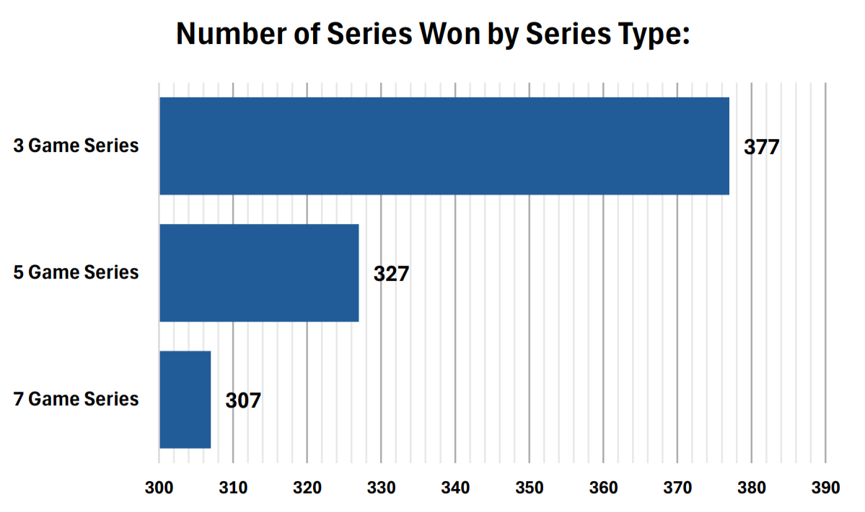  
Analysis here

(Figure 3 - Line Graph: Series Length vs % Of Series Won)

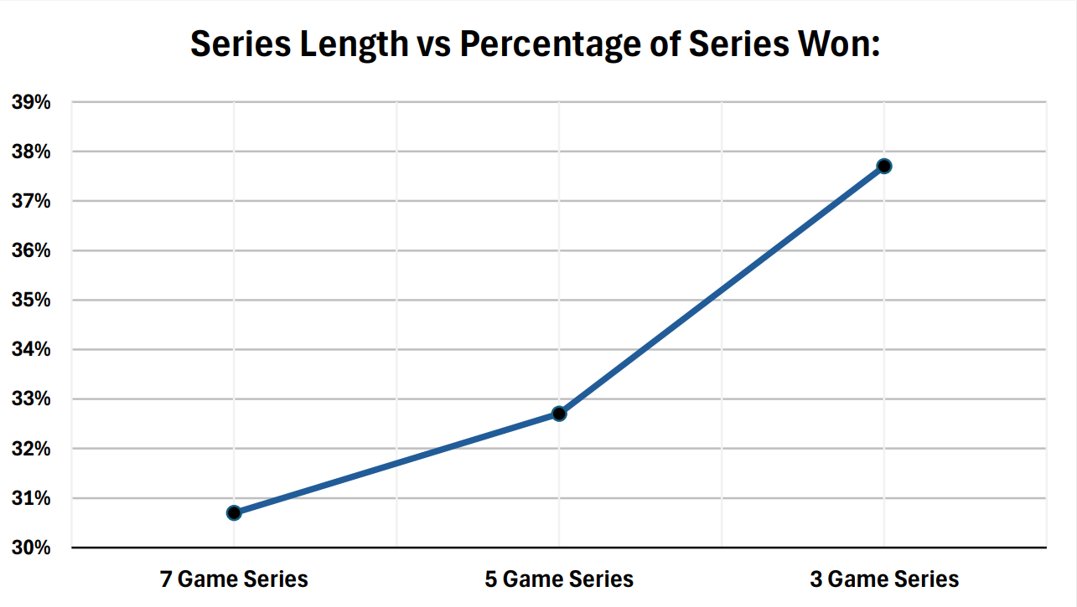  
Analysis here

# Discussion:

The results strongly support the claim that weaker teams have a better chance of winning in shorter competitions, aligning with both theoretical expectations and real-world stories of underdog success. This phenomenon is attributed to higher variance in smaller samples; fewer games allow luck to play a larger role, enabling upsets. Conversely, longer series dilute randomness, allowing superior skill to dominate.

The inverse correlation between series length and underdog success highlights the trade-off between fairness and unpredictability. For instance, the 3-game series’ 37.7% win rate – a full 7% point higher than the 7-game format – demonstrates how a shorter competition magnifies variance. This mirrors single-elimination tournaments like the FIFA World Cup, where miraculous underdog victories (e.g. Morocco’s 2022 run) are more frequent due to high-stakes, short-format matches. In contrast, leagues with prolonged seasons, such as the NBA’s 82-game schedule, rarely see underdogs clinch titles, as consistent performance outweighs sporadic luck.

# Critique:

The simulation’s results closely align with what binomial probability predicts (with deviations no more than 2.5%), confirming that the simulation is mathematically sound. By grounding the analysis in the Chicago Bulls’ 40% win rate, the model maintains practical relevance to real-world scenarios. The results seen give explanation to the observations of real-world underdog success, as well as the assumptions guiding the model’s design. However, there are several considerable limitations tied to the assumptions made throughout the investigation:

* **Static Win Probability:** The assumption of a fixed 40% win rate ignores dynamic factors like home-court advantage, player fatigue, or tactical adjustments mid-series. Other important aspects such as momentum shifts, pressure dynamics, and team morale – critical in actual competitions – are absent in the model. The absence of these factors could have a decisive effect on outcomes.
* **Simplified Competition Structure:** Real tournaments (like the NBA playoffs) often involve multi-round formats with reseeding or varying opponents, which could alter underdog trajectories.